**Experiment No : 7**

**AIM**

Familiarization of LINUX Commands.

**CO2**

Perform system administration task.

**Procedure**

1. expr

evaluates the given expression and displays the output.

$ expr 12 + 8

Output

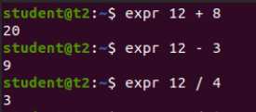

* 1. expr [$ variable1] [$ variable2]

evaluates the expression and returns value.

$ expr $x + $y

Output

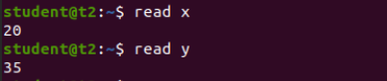



2) df

Shows the disk utilization of our system in terms of used space, megabits etc.

$ df

Output

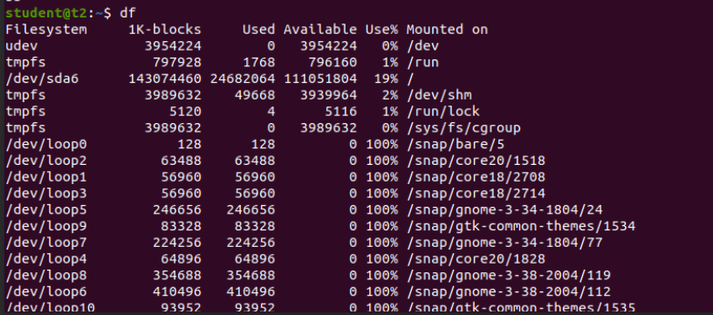

3) du [filename]

Shows the disk utilization of a specific file

$ du

Output



4) sudo

To add new user to the system

4.1) sudo useradd [username]

Adds a user to the Ubuntu system specified by the user.

$ sudo useradd nithasha

Output

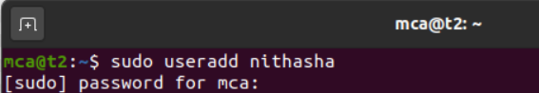

4.2) sudo passwd [username]

To update the password of new user

$ sudo passwd nithasha

Output

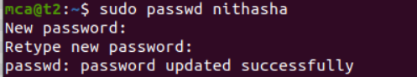

4.3) sudo groupadd –g [gid] [group name]

To create a group with a unique identifier. User would be notified if it already exists.

$ sudo groupadd –g 765 mcacommunity

Output

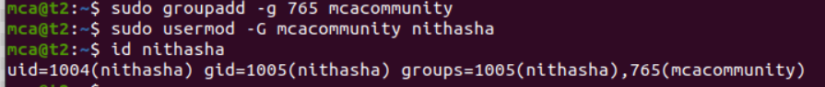

4.4) sudo usermod –G [group name] [member user]

To add any existing user to the group created.

$ sudo usermod –G mcacommunity Nithasha

Output



5) id [username]

Displays the group name and group id to which the user belongs to.

$ id nithasha

Output



6) compgen –g

Displays all the groups

Output

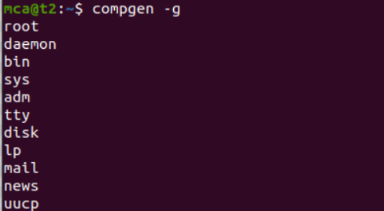

7) chmod

Used to change the access permissions of files and directories. It stands for change mod( read ( r ), write ( w ), execute ( x )..etc ).

7.1) chmod –wx [filename]

This command denies permission to write or append to the file.

$ chmod –wx file

Output

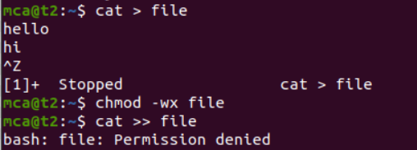

7.2) chmod +wx [filename]

This command allows permission to write or append to the file.

$ chmod +wx file

Output

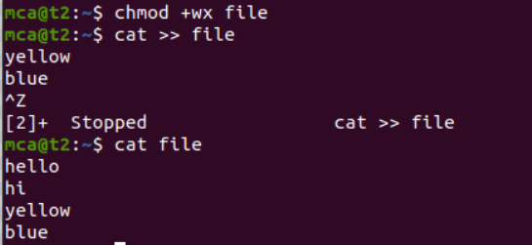

8) chown

Command used to change a file ownership or directory ownership for a user or a group. chown stands for change owner.

8.1) sudo chown [username] [filename]

Changes the file ownership from the current user to another.

$ sudo chown nithasha file

Output



Result

The program has been executed and output has been verified.